Project Report On

"Smart Test Quiz "

Submitted to Punjab Technical University, Jalandhar

##### In partial fulfillment of the requirements For the degree of

B.Tech Computer Science & Engineering (Session 2020-2024)



##### Submitted To: Miss Punita Singh Submitted By: Himanshu Kashyap

##### B.Tech (CSE)

##### (2026581)

##### PCTE INSTITUTE OF ENGINEERING & TECHNOLOGY, LUDHIANA

Declaration

I swore that the work being presented by me in the dissertation titled "**Smart Test Quiz**” in partial requirements for the fulfillment of degree of B.Tech Computer Science and Engineering to be submitted in **PCTE INSTITUTE OF ENGINEERING AND TECHNOLOGY, LUDHIANA** affiliated to **PTU,**

**Jalandhar** is authentic record of my own work carried out by me under the supervision of **"Ms. Punita Singh".**

#### Acknowledgement

On the very outset I would like to thank the almighty GOD for showering his blessing & providing me with the courage, motivation & strength to complete my project.

Every Project work demands a lot of hard work, time, patience and concentration. While working on this seminar, apart from these aspects, I have developed necessary skills and attitude, which are always required in a professional field. I am thankful to all those who helped me in completing this project.

I express my deep sense of gratitude & indebtness towards my respected Project In-charge " **Ms. Punita Singh** ", and faculty members of PCTE Institute of Engineering and Technology from whom I have learnt the technical skills for completion of this Project. Without their guidance, I would have found it really difficult to undertake the project work. I would like to thank them for their ever available, unconditional help & guidance that they made available throughout the project work.

I would also like to acknowledge the encouraging attitude of my friends & other staff members of P.C.T.E family that helped me to complete the project work.

#### Certificate from Organization

This is to certify that format and quality of presentation of project report submitted by

As one of the requirements for the degree of **B.Tech Computer Science and Engineering** is acceptable to

##### Department of Computer Science and Engineering, PCTE, Ludhiana

##### Head of Dept.

##### ( )

##### PCTE Institute of Engineering and Technology, Ludhiana

#### Certificate from Internal Guide

This is to certify that the project title “**Smart Test Quiz**” submitted for the degree of **B.Tech Computer Science and Engineering** in the project of **PCTE Institute of Engineering and Technology, Ludhiana** affiliated to **PTU, Jalandhar** is a benefited research which is carried out by me and no part of this project has been for any other degree. I have worked very hard and sincerely during this project.

##### Project Supervisor

##### (Miss Punita Singh) (Faculty, PCTE) Ludhiana

Contents

Introduction 1

Introduction to project 1

Purpose of the project 2

Problem in existing system 3

System specifications 5

Features of Project 6

Project Planning 7

File Structure Definition 9

Documentation 11

Introduction to technology 12

ER(Entity Relationship Diagram) 18

DFD (Data Flow Diagram) 19

Website Snapshots 21

User 21

Admin 27

Database Tables 31

Limitations 37

Future Scope 41

Conclusion 44

References 45

# Introduction

## Introduction to project

Welcome to Smart Test, the premier online platform for multiple-choice question (MCQ) based quizzes and exams. Designed with both students and administrators in mind, Smart Test offers an intuitive and user-friendly experience that simplifies the process of taking and managing tests.

For students, Smart Test provides a seamless interface to take tests across a variety of subjects, track their progress, and review results with detailed feedback. The platform's adaptive design ensures that learners can focus on their studies, practicing and improving their knowledge and test-taking skills.

Administrators, on the other hand, have complete control over the platform's functionalities. They can effortlessly add new tests, subjects, and questions, tailoring the quizzes to meet the specific educational needs of their institution. With comprehensive access to all results and analytics, admins can monitor student performance, identify trends, and make informed decisions to enhance the learning experience.

Join Smart Test today and revolutionize the way educational assessments are conducted, ensuring a smarter, more efficient, and engaging approach to learning and evaluation.

## Purpose of the project

The purpose of creating the Smart Test Quiz App is to revolutionize the way educational assessments are conducted on online platforms by providing a secure, efficient, and comprehensive solution for both students and administrators. This innovative app is designed with the following objectives in mind:

1. Enhance Accessibility and Convenience: By offering a platform for online MCQ- based tests, Smart Test makes it easier for students to access and take exams from anywhere, at any time. This flexibility is crucial in today's digital age, where remote learning and assessments have become increasingly prevalent.
2. Ensure Security and Integrity: The app incorporates robust security measures to ensure the integrity of the testing process. Features such as secure login, timed tests, and anti-cheating mechanisms are implemented to maintain a fair and honest examination environment.
3. Empower Administrators with Full Control: Administrators have comprehensive control over the app’s functionalities, allowing them to add new tests, subjects, and questions with ease. This level of control ensures that the content remains up-to- date and relevant, tailored to the educational needs of the institution.
4. Streamline Test Management and Evaluation: The app simplifies the process of managing and evaluating tests. Administrators can easily monitor student performance, view detailed results, and generate analytical reports to gain insights into learning outcomes and trends.
5. Enhance Learning Outcomes: By providing immediate feedback and detailed analytics, Smart Test helps students identify their strengths and areas for improvement, fostering a more personalized and effective learning experience.
6. Support Remote and Blended Learning: In an era where remote and blended learning models are becoming the norm, Smart Test provides a reliable platform that supports these educational approaches, ensuring continuity and quality of education regardless of location.

Overall, the Smart Test Quiz App aims to provide a seamless, secure, and efficient solution for online assessments, empowering administrators with the tools they need to manage the entire testing process while offering students a convenient and effective way to demonstrate their knowledge and skills.

## Problem in existing system

There are several common issues and limitations found in existing online test quiz apps that Smart Test aims to address. These problems include:

1. Lack of Security:
   * Many existing apps do not have robust security measures in place, making it easier for students to cheat. This can include weak authentication processes, inadequate monitoring during tests, and insufficient protection against unauthorized access.
2. Limited Administrator Control:
   * Administrators often face limitations in managing tests, subjects, and questions. Some platforms do not provide easy-to-use interfaces for adding or modifying

content, which can lead to outdated or irrelevant material being used in assessments.

1. Poor User Interface and Experience:
   * The user interfaces of some quiz apps are not intuitive or user-friendly, leading to a frustrating experience for both students and administrators. This can affect the efficiency of taking and managing tests.
2. Inadequate Feedback and Analytics:
   * Many platforms do not offer detailed feedback or comprehensive analytics on test results. This limits the ability of students to understand their performance and areas for improvement, and it hampers administrators' capacity to make data-driven decisions.

Smart Test is designed to overcome these challenges by providing a secure, user- friendly, and highly customizable platform with robust administrative controls and comprehensive analytics to enhance the overall experience and effectiveness of online testing.

# System specifications

**Hardware requirements:**

Minimum Hardware Specifications for Developing a PHP-based Project

1. Processor (CPU):

- Development Machine: Dual-core (e.g., Intel Core i3 or equivalent) or higher

1. Memory (RAM):
   * Development Machine: 4 GB minimum, 8 GB recommended
2. Storage:
   * Development Machine: 250 GB HDD minimum, 256 GB SSD recommended

**Software requirements:**

Software Requirements for Developing a PHP-based Project

1. Operating System:
   * Windows 10 or later, macOS, or a Linux distribution (e.g., Ubuntu, Fedora).
2. Web Server:
   * Apache or Nginx.
3. Database:
   * MySQL, MariaDB, or PostgreSQL.
4. PHP:
   * PHP 7.4 or later, with necessary extensions (e.g., PDO, mbstring, curl).
5. Development Tools:
   * IDE/Code Editor (e.g., Visual Studio Code, PhpStorm), Git, Composer (for PHP dependency management).

# Features of Project

Features of the Smart Test Quiz App

1. Authentication and Authorization:
   * Secure login system for students and administrators.
   * Role-based access control to ensure that only authorized users can access specific functionalities.
2. Interactive User Interface (UI):
   * User-friendly and intuitive interface for easy navigation.
   * Responsive design to ensure compatibility across various devices and screen sizes.
3. Ease of Access for Admin Controls:
   * Comprehensive admin dashboard for managing all aspects of the platform.
   * Easy-to-use tools for adding and modifying tests, subjects, and questions.
   * Real-time analytics and reporting on student performance and test results.
4. Subject-wise Test Management:
   * Capability to create and manage tests across multiple subjects.
   * Option for admins to organize questions into different subjects and topics.
5. Timer on Each Question:
   * Customizable timer settings for each question to enhance exam integrity.
   * Visual countdown timer displayed to students during tests.
6. User Activity Monitoring:
   * Admins can view the number of registered users on the platform.
   * Detailed statistics on how many users have taken each test.
   * Insights into user engagement and activity trends.

# Project Planning

Project Planning for Smart Test Quiz App

* + - Understanding the Topic
    - Modular Break-up of the System
    - Process Logic for Each Module
    - File Structure Definition
    - Documentation

Understanding the Topic

Smart Test Quiz App is designed to provide an online platform for conducting multiple-choice question (MCQ) based quizzes and exams. The app offers features such as authentication, authorization, an interactive user interface, ease of access

to admin controls, subject-wise test management, timers on questions, and user activity monitoring.

Modular Break-up of the System

1. User Management Module:
   * Authentication and Authorization: User registration, login, password management, and role-based access control.
   * User Profile Management: Updating user details and preferences.
2. Admin Dashboard Module:
   * User Activity Monitoring: Viewing registered users and test participation statistics.
   * Test Management: Creating, updating, and deleting tests, subjects, and questions.
3. Quiz Management Module:
   * Test Creation and Management: Organizing tests by subjects, adding questions, and setting test parameters.
   * Timer Management: Configuring timers for individual questions or entire tests.
4. Student Interface Module:
   * Test Taking Interface: Interactive UI for students to attempt quizzes, navigate between questions, and submit tests.
   * Result Viewing: Displaying test results and feedback.
5. Analytics and Reporting Module:
   * Performance Analytics: Generating reports on student performance, test statistics, and overall user engagement.

Process Logic for Each Module

1. User Management Module:
   * Authentication and Authorization: Verify credentials, assign roles, and manage sessions.
   * User Profile Management: CRUD operations for user profiles.
2. Admin Dashboard Module:
   * User Activity Monitoring: Fetch and display data on registered users and test participation.
   * Test Management: CRUD operations for tests, subjects, and questions.
3. Quiz Management Module:
   * Test Creation and Management: Define test parameters, organize questions, and save configurations.
   * Timer Management: Implement countdown timers for questions/tests and enforce time limits.
4. Student Interface Module:
   * Test Taking Interface: Render questions, handle user input, and manage navigation.
   * Result Viewing: Calculate scores and display feedback.
5. Analytics and Reporting Module:
   * Performance Analytics: Collect and process data to generate insights and reports.

## File Structure Definition

/Smart Test-app

├── /admin

│ ├── dashboard.php

│ ├── manage-users.php

│ ├── manage-tests.php

│ ├── view-reports.php

│ └── ...

├── /student

│ ├── take-test.php

│ ├── view-results.php

│ └── ...

├── /includes

│ ├── header.php

│ ├── footer.php

│ ├── db-config.php

│ ├── auth-functions.php

│ └── ...

├── /assets

│ ├── /css

│ │ └── styles.css

│ ├── /js

│ │ └── scripts.js

│ ├── /images

│ └── ...

├── index.php

├── login.php

├── register.php

└── ...

```

### Documentation

1. User Manual:
   * Instructions for students on how to register, log in, take tests, and view results.
   * Guidelines for administrators on how to manage users, create tests, and view analytics.
2. Technical Documentation:
   * Detailed descriptions of the system architecture and module interactions.
   * Database schema and ER diagrams.
   * API documentation for any external integrations.
   * Code comments and inline documentation for key functions and processes.
3. Project Reports:
   * Initial project proposal and scope.
   * Requirement specifications.
   * Development timeline and milestones.
   * Testing plans and results.
4. Maintenance Guide:
   * Procedures for updating and maintaining the system.
   * Troubleshooting common issues.
   * Backup and recovery processes.

# Introduction to technology

**HTML, CSS & JS**

HTML (HyperText Markup Language) is the foundational language used to create the structure of web pages. It is essential for defining the layout and content of the website, ensuring that elements such as headings, paragraphs, links, and images are properly organized.

In this job portal project, HTML plays a crucial role in several areas:

Structuring Content: HTML is used to organize and structure the content of the job portal, providing a logical and accessible layout. It defines the semantic structure of the web pages, making it easier for search engines to index the site and for users to navigate it.

Embedding Media: HTML tags enable the embedding of various media elements, such as images, videos, and audio files. This enhances the visual appeal and multimedia capabilities of the website, creating a more engaging user experience. Creating Forms: HTML forms are essential for collecting user inputs, such as login credentials, job application details, and feedback. These forms are the primary means of user interaction with the backend of the website.

Linking Resources: HTML provides the ability to create hyperlinks, connecting different pages and resources within the job portal. This ensures seamless navigation and a cohesive user experience.

Integrating Scripts: HTML allows the integration of JavaScript and CSS, enabling dynamic content and interactive features, as well as styling the web pages.

CSS (Cascading Style Sheets) is the language used to control the presentation and layout of web pages. It works alongside HTML to enhance the visual aesthetics

and usability of the job portal. In this project, CSS is utilized in various ways:

Styling Elements: CSS is applied to style HTML elements, including text, buttons, forms, and other UI components. This ensures consistent and visually appealing design across the website.

Responsive Design: CSS media queries are used to create a responsive layout, ensuring that the job portal looks and functions well on various devices and screen sizes. This is critical for providing a seamless experience to users, regardless of the device they use.

Custom Themes: CSS allows for the creation of custom themes, giving the job portal a unique and professional appearance. Custom themes can be tailored to match the brand identity and enhance the overall visual coherence of the site. Animations and Transitions: CSS is used to implement smooth animations and transitions, improving the interactivity and engagement of the website. These effects can enhance user interactions and make the website feel more dynamic and modern.

Grid and Flexbox Layouts: CSS grid and flexbox systems are employed to create flexible and complex layouts, ensuring that content is displayed in a structured and organized manner.

JavaScript is a powerful scripting language that enables interactive and dynamic

functionalities on web pages. It is essential for enhancing user experience and adding advanced features to the job portal. In this project, JavaScript is employed in several key areas:

Client-Side Interactions: JavaScript enhances user interactions, such as form validation, dynamic content updates, and interactive features. It allows for real- time feedback and actions, improving the overall user experience.

AJAX Requests: JavaScript is used to make asynchronous requests to the server, allowing for real-time data updates without reloading the entire page. This is crucial for functionalities like dynamic job searches, real-time notifications, and live updates.

User Experience Enhancements: JavaScript libraries and frameworks, such as jQuery, are used to create smooth animations and interactive elements. These enhancements improve the overall user experience by making the website more engaging and user-friendly.

Handling Events: JavaScript is used to handle various user events, such as clicks, form submissions, and mouse movements. This allows for responsive and interactive web pages that react to user inputs in real-time.

Data Manipulation: JavaScript is used to manipulate and display data dynamically on the client-side, ensuring that users always see the most up-to-date information without needing to refresh the page.

**Bootstrap**

Bootstrap is a powerful front-end framework used for developing responsive and mobile-first web applications. It provides a collection of CSS and JavaScript components, as well as pre-designed templates, which help developers create visually appealing and functional websites quickly and efficiently. In this job portal project, Bootstrap is utilized in several key areas:

Responsive Design: Bootstrap’s responsive grid system ensures that the job portal looks and functions well on various devices and screen sizes. The grid system allows for the creation of flexible layouts that adapt to different screen resolutions, providing an optimal viewing experience on desktops, tablets, and smartphones.

Pre-designed Components: Bootstrap includes a wide range of pre-designed components, such as navigation bars, buttons, forms, modals, carousels, and more. These components are used to build the user interface of the job portal, ensuring a consistent and professional look throughout the site.

Customizable Themes: Bootstrap allows for the creation of custom themes by modifying its default styles. This customization capability enables the job portal to maintain a unique and branded appearance, tailored to the specific aesthetic requirements of the project.

Cross-browser Compatibility: Bootstrap is designed to be compatible with all modern browsers, ensuring that the job portal works seamlessly across different web platforms. This reduces the time and effort needed to test and fix browser- specific issues.

Enhanced UI Elements: Bootstrap provides enhanced UI elements, such as tooltips, popovers, alerts, and progress bars, which are used to improve user

interactions and provide additional information to users. These elements contribute to a more interactive and user-friendly experience.

Consistent Design Language: By using Bootstrap, the job portal maintains a consistent design language throughout all its pages and components. This consistency helps in creating a cohesive and professional user interface that is easy to navigate and understand.

JavaScript Plugins: Bootstrap includes a variety of JavaScript plugins that add advanced functionalities to the website, such as modals, dropdowns, carousels, and tabs. These plugins enhance the interactivity and functionality of the job portal without requiring extensive custom JavaScript code.

Documentation and Community Support: Bootstrap has extensive documentation and a large community of developers, which provides valuable resources, tutorials, and support. This makes it easier to troubleshoot issues, find solutions, and implement best practices in the development of the job portal.

**PHP and MySQL**

PHP (Hypertext Preprocessor) is a server-side scripting language used for backend development and database interactions. It is a critical component of the job portal, enabling various server-side operations:

Server-Side Logic: PHP handles server-side operations, including form processing, session management, and user authentication. It ensures that user inputs are securely processed and that sessions are managed effectively.

Database Connectivity: PHP is used to connect to the MySQL database, enabling data retrieval, insertion, and manipulation. This is essential for managing job postings, user profiles, applications, and other data-driven functionalities.

Dynamic Content Generation: PHP generates dynamic content based on user interactions, ensuring a

personalized experience for each user. This includes generating user-specific pages, processing search queries, and displaying relevant job listings.

File Handling: PHP is used for server-side file handling operations, such as uploading user resumes, storing documents, and managing media files.

Security Measures: PHP includes various security measures, such as input validation, prepared statements, and session management, to protect against common web vulnerabilities.

MySQL is a popular relational database management system used to store and manage data for web applications. In this job portal project, MySQL is employed for:

Data Storage: MySQL stores all the data related to job postings, user profiles, applications, and interactions within the job portal. It ensures that data is stored in a structured and organized manner.

Data Retrieval: SQL queries are used to retrieve data from the database, providing real-time information to users. This is essential for displaying job listings, user profiles, and application statuses.

Data Manipulation: MySQL allows for efficient data manipulation, enabling operations such as updating job postings, editing user profiles, and processing applications.

Data Security: MySQL offers robust security features, ensuring the protection and integrity of the data stored in the database. This includes user authentication, data encryption, and access control mechanisms.

Performance Optimization: MySQL includes various performance optimization features, such as indexing, query optimization, and caching, to ensure fast and efficient data retrieval and manipulation.

Scalability: MySQL is highly scalable, allowing the job portal to handle increasing amounts of data and user traffic as it grows.

By leveraging these technologies, the job portal is designed to provide a seamless, efficient, and engaging experience for all users, whether they are job seekers, recruiters, or administrators. Each technology plays a vital role in ensuring that the portal is robust, secure

# ER(Entity Relationship Diagram)

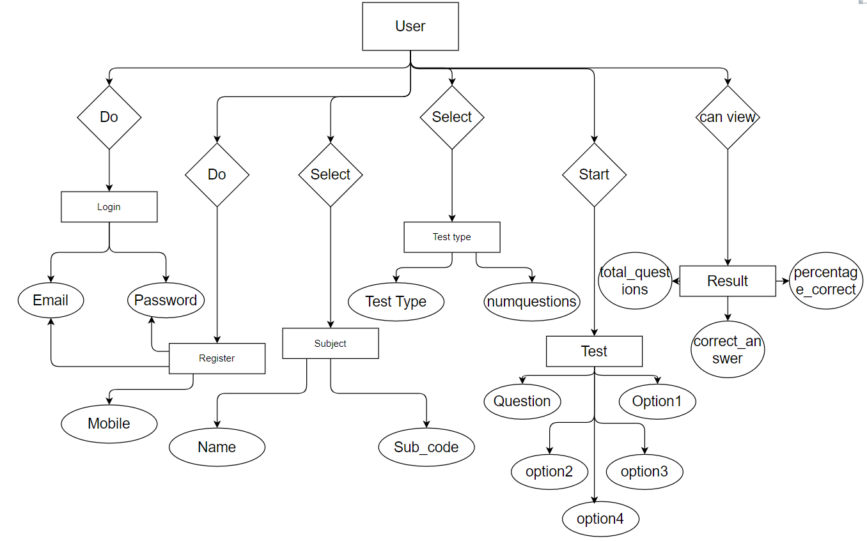

# DFD (Data Flow Diagram)

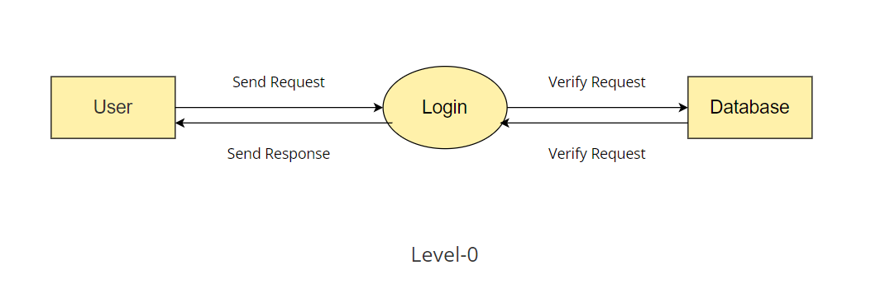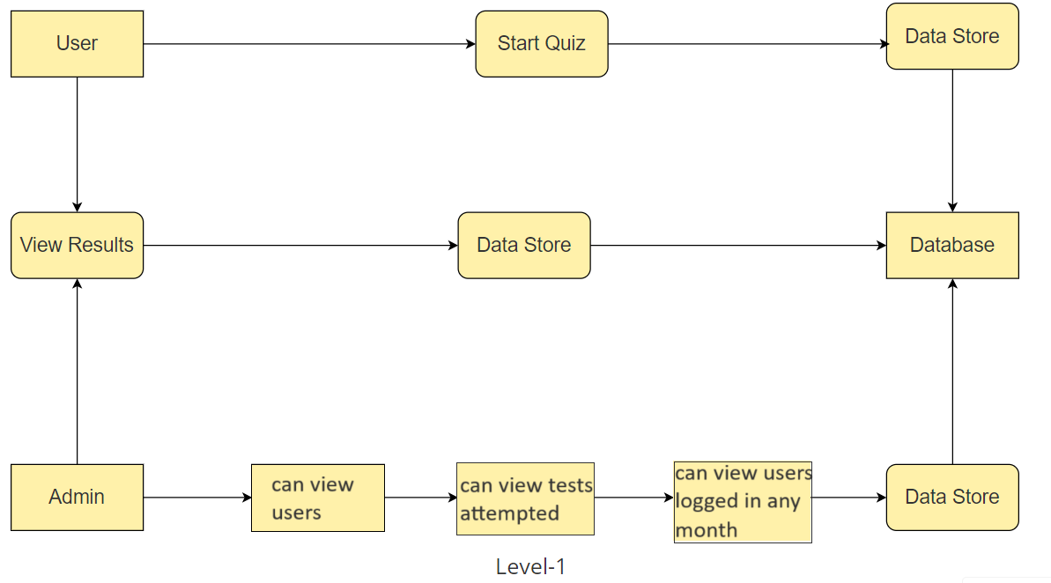DFD Level-0

DFD Level-1

DFD Level-2

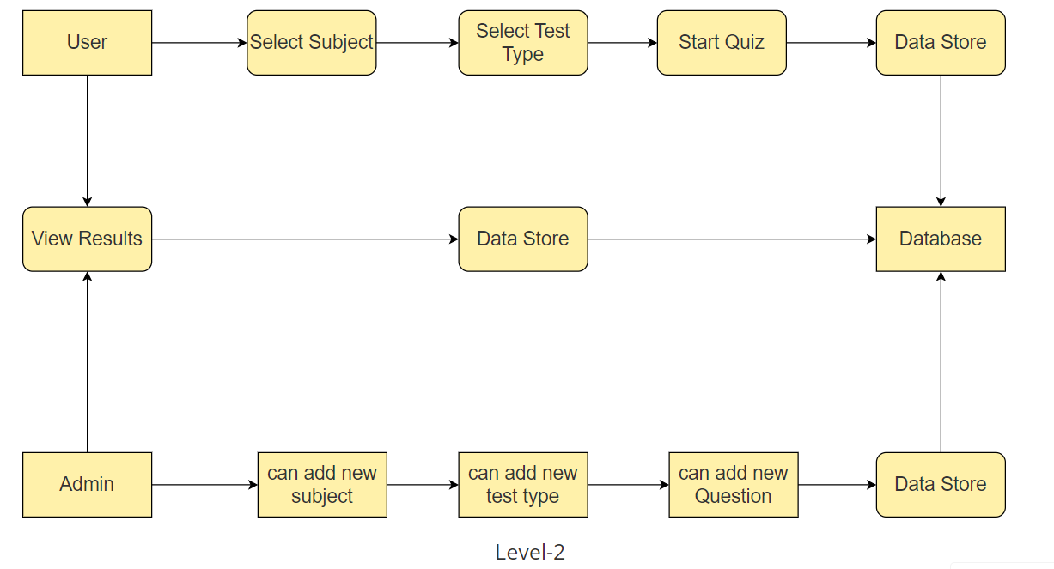

# 

# Website Snapshots

## User

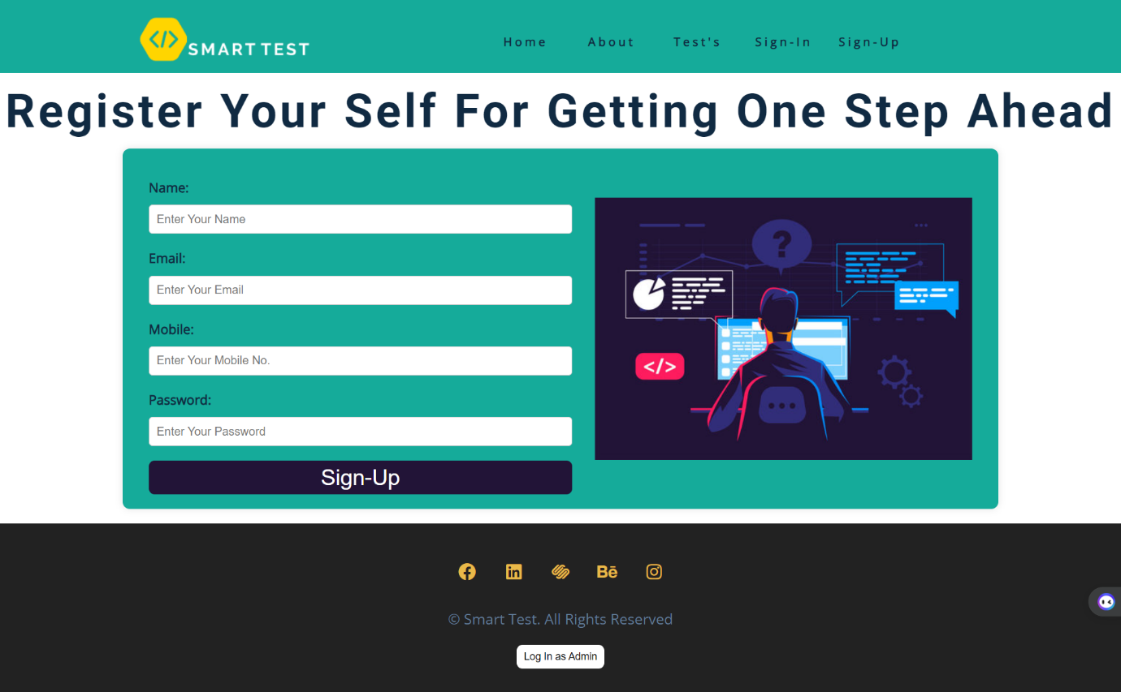This is the user sign up page through which user can register himself or herself.

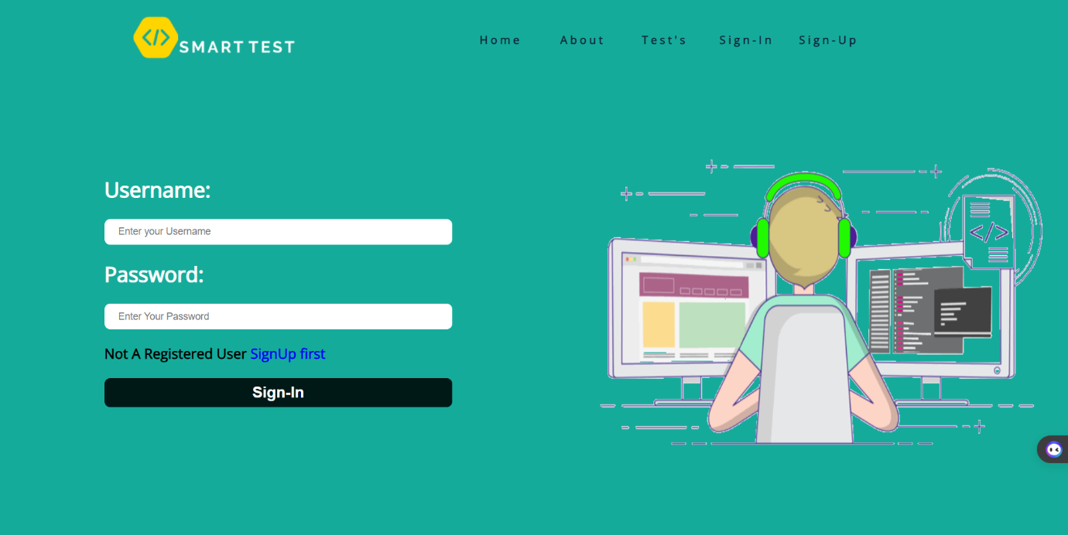After signing up the user will be redirected to sign in page through which he will log in to the website.

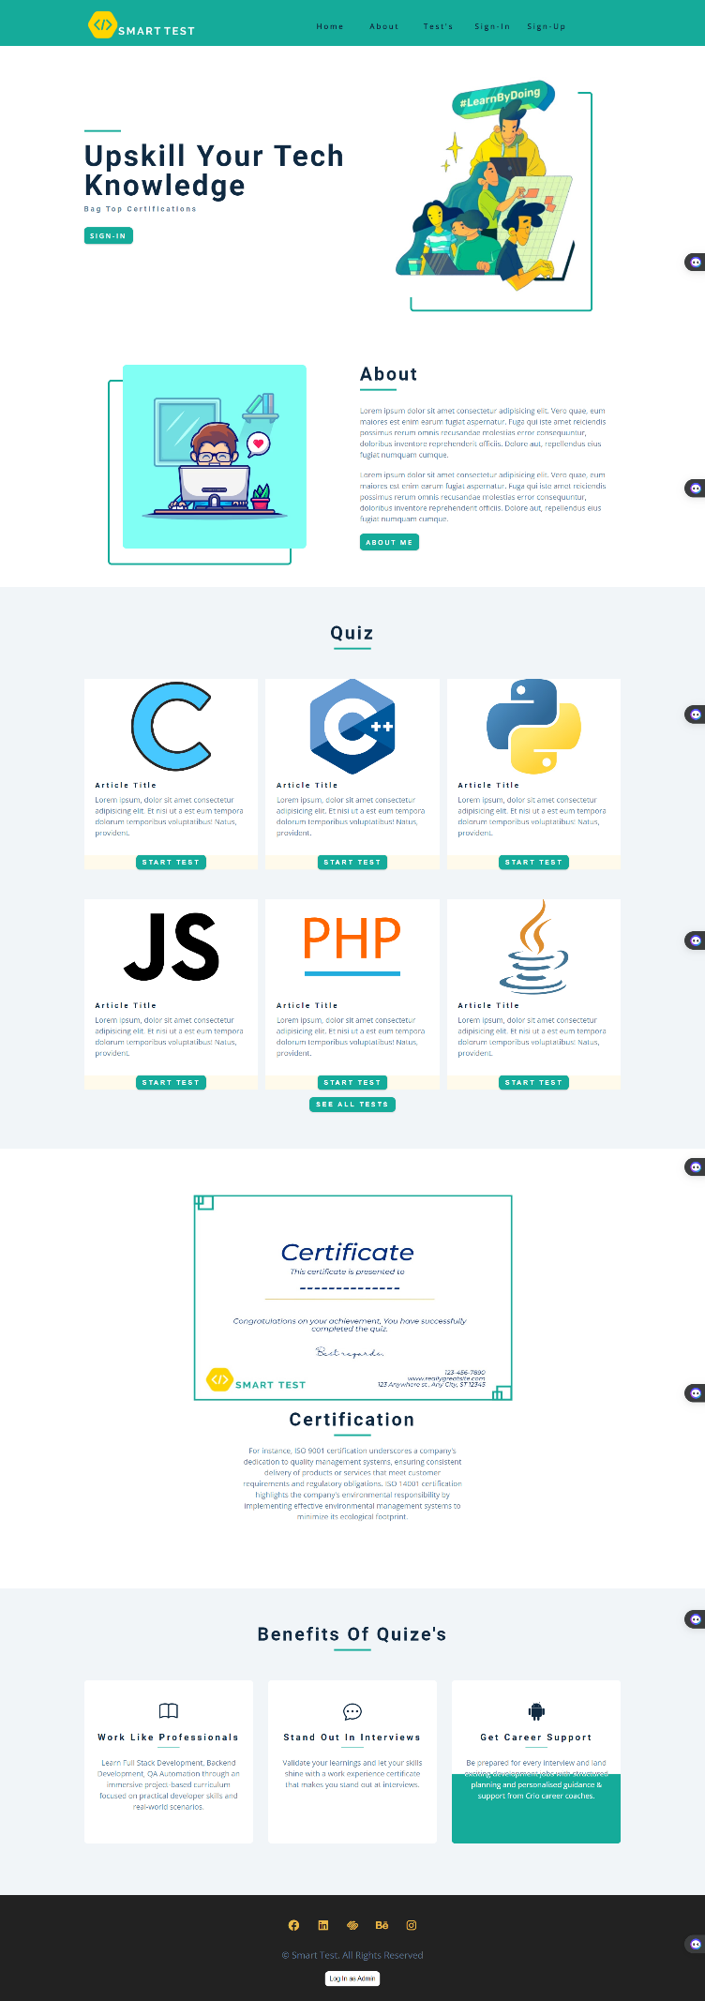

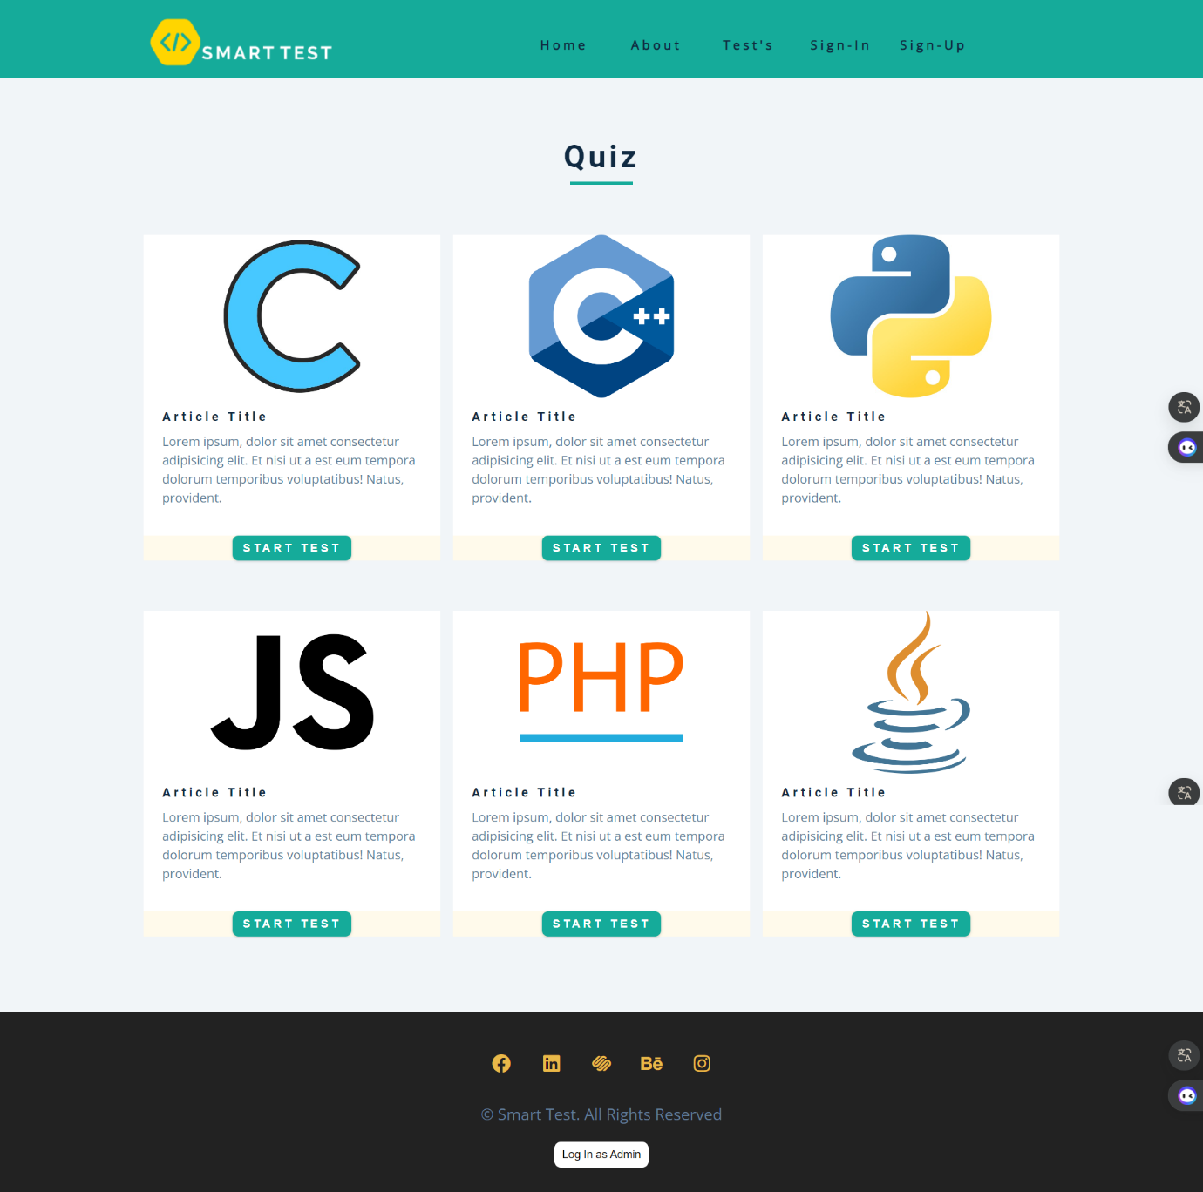This is test page where various tests are placed before login the button start test will render you to sign in page but after login you can successfully attempt the test.

After Login

After login you will see your name in navbar and a logout and view results button would appear in navbar.

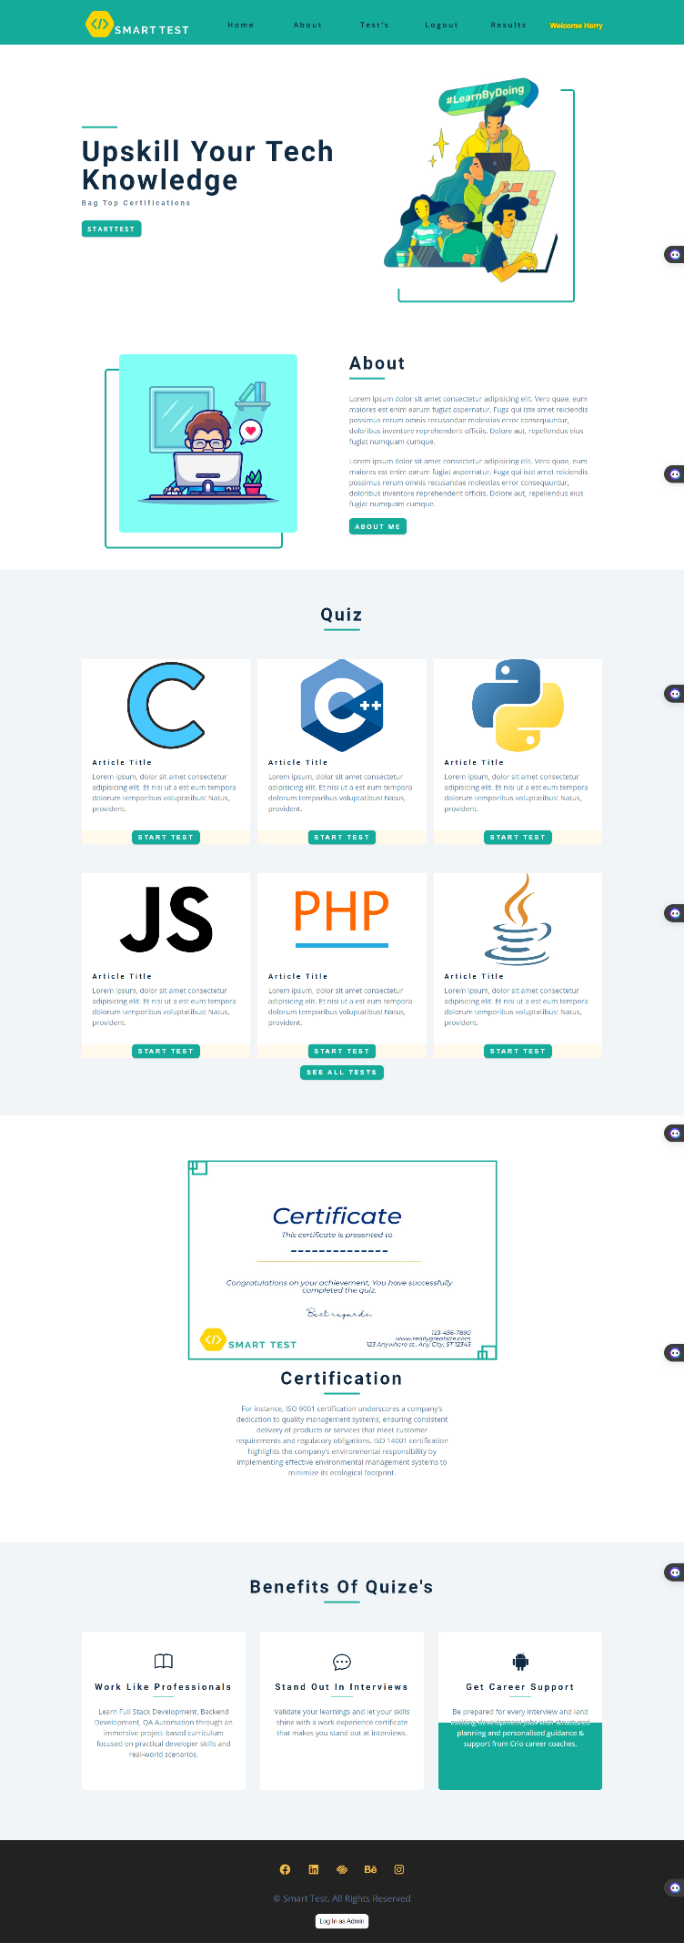Now user can start test by selecting the subject.

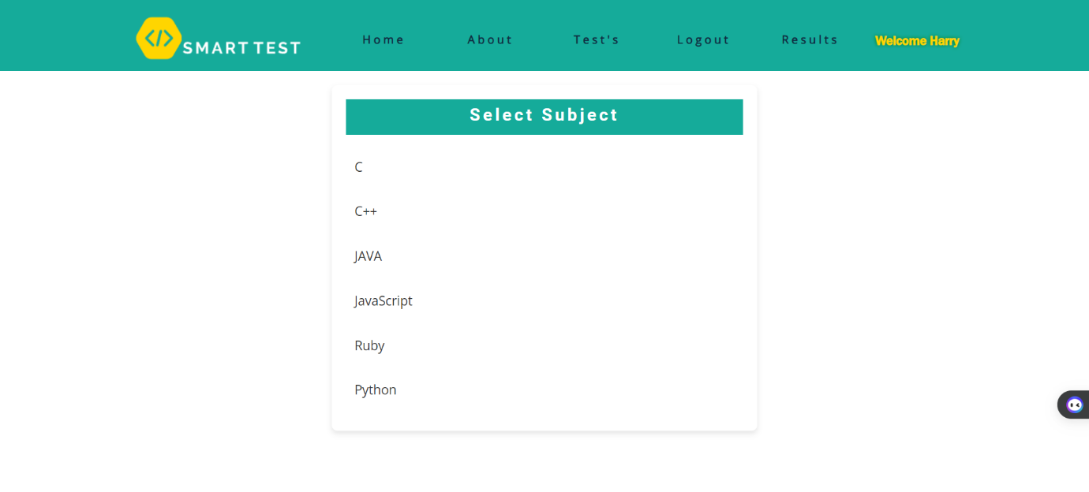After selecting the subject he can select the test type he want to appear for.

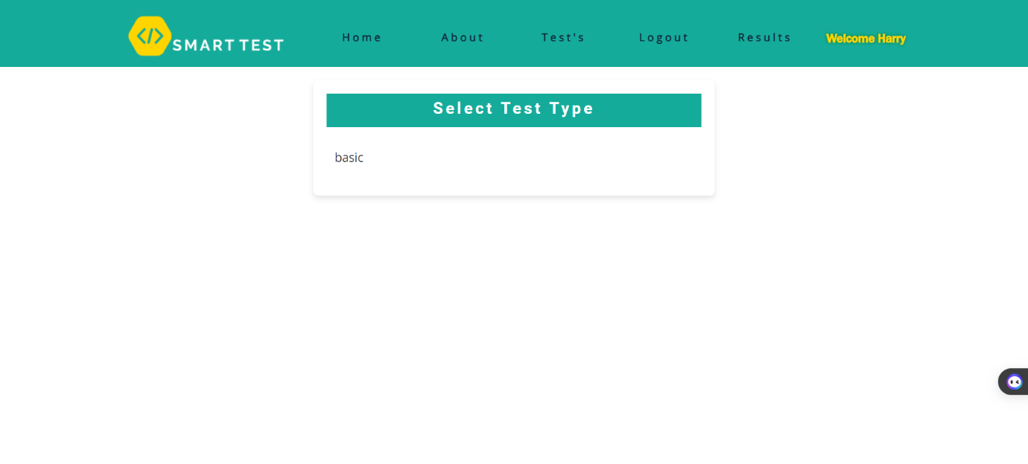

After selecting the subject questions similar to test type will appear with a timer of 30seconds. After the timer runs out that question is marked as 0.

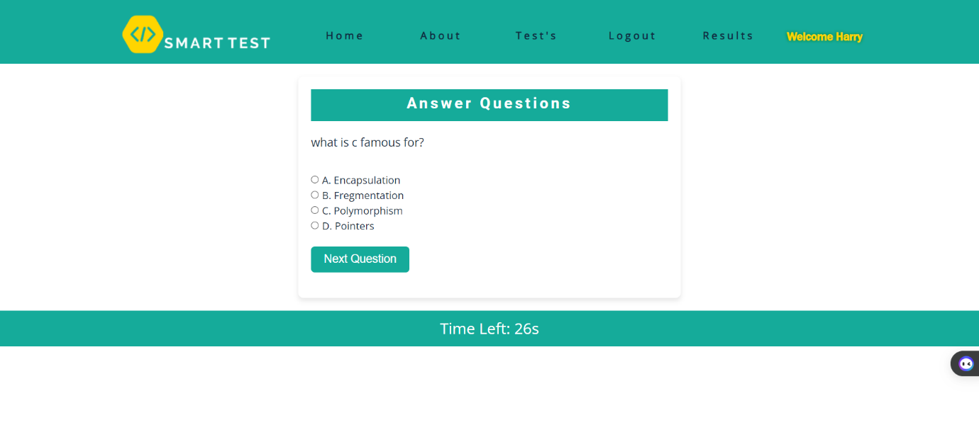

After the test completing user will be able to see his/her marks total questions correct answers and percentage.

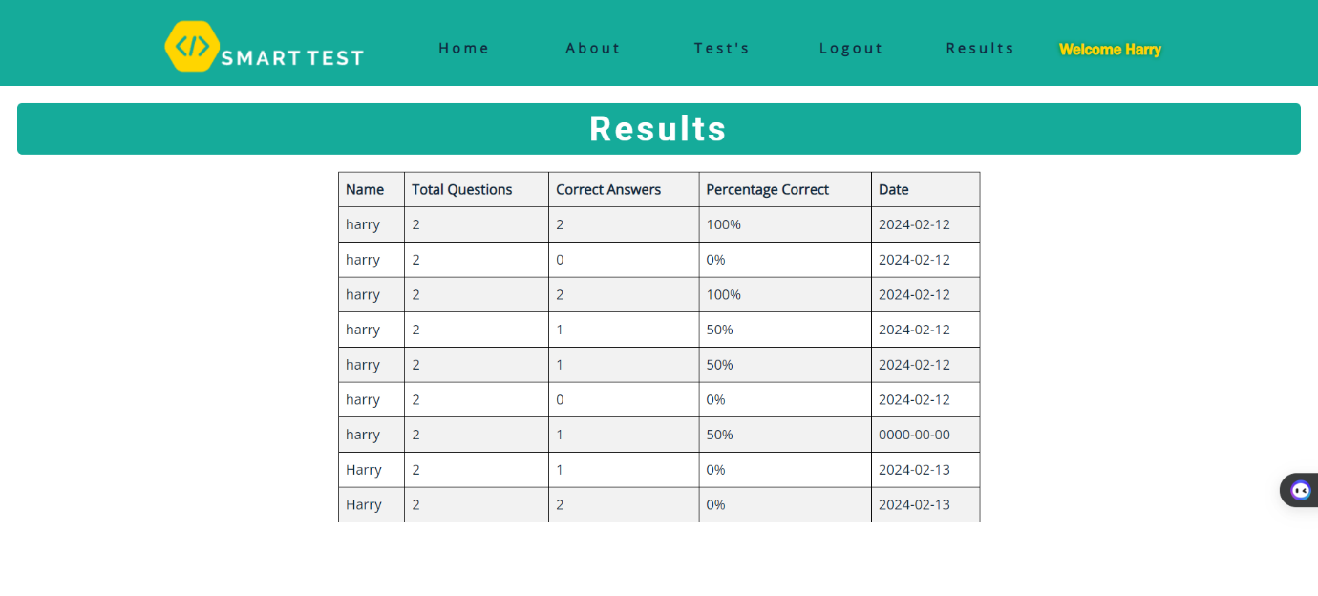

## 

## Admin

Admin will login through it’s username and password.

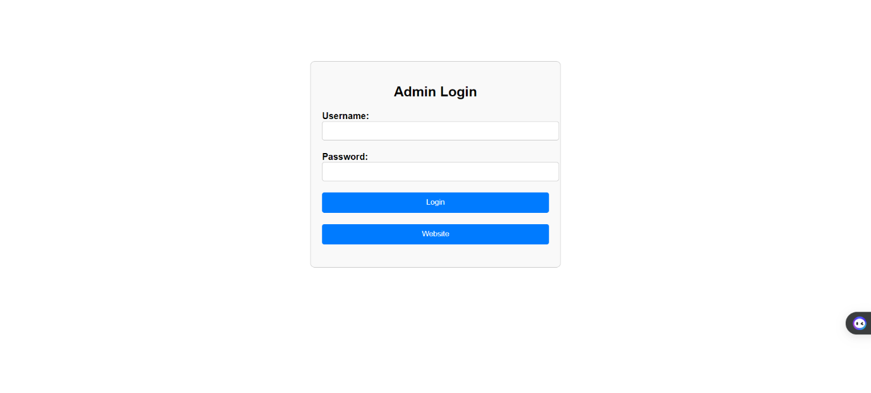

After logging in dashboard of admin will appear where he will be able to see total no. of users logged in and total no. of test attempted.

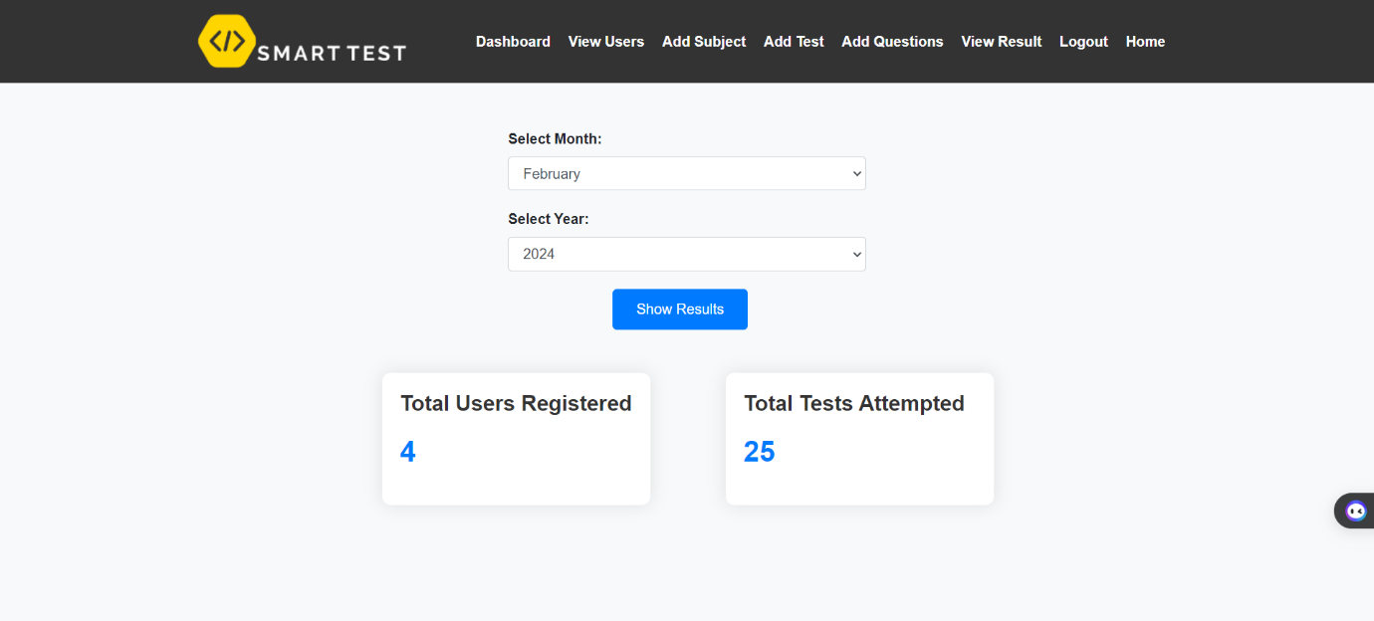

Now admin can view all the users through his panel.

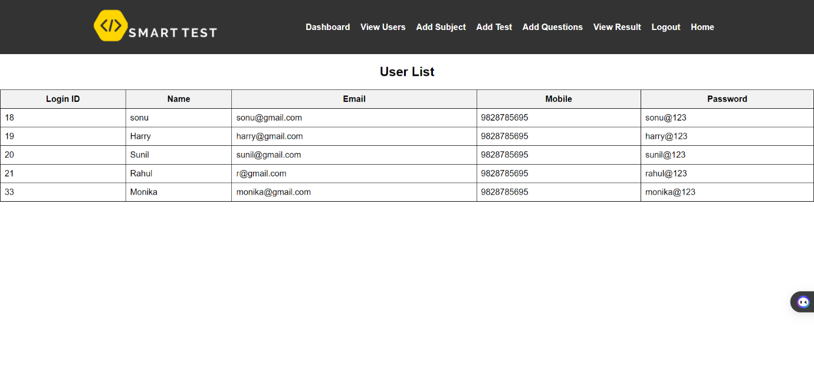

Admin can add more subjects for the test and they will reflect to the user and can also edit it.

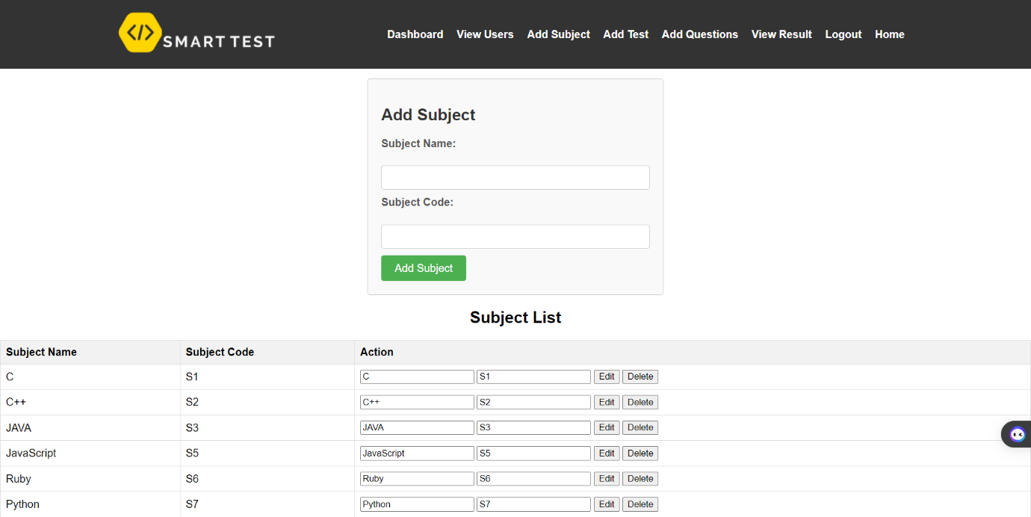

Admin can also add more test types for the user and can also edit them.

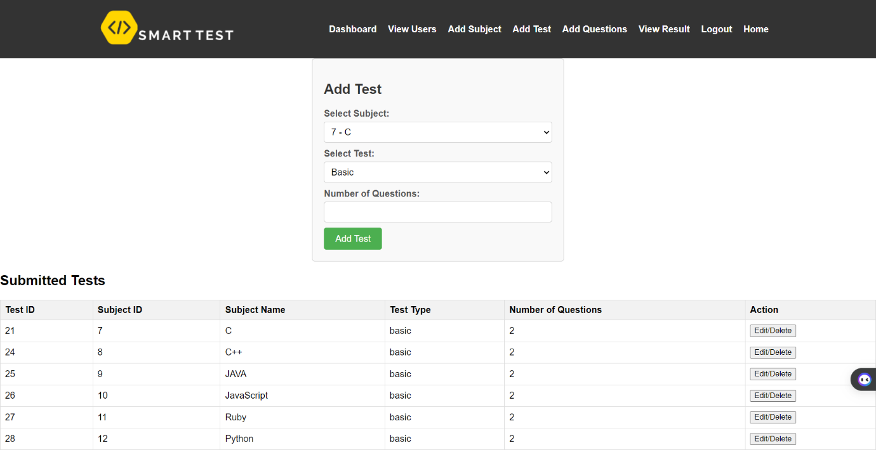

Admin can add questions add options and can also edit them according to the need.

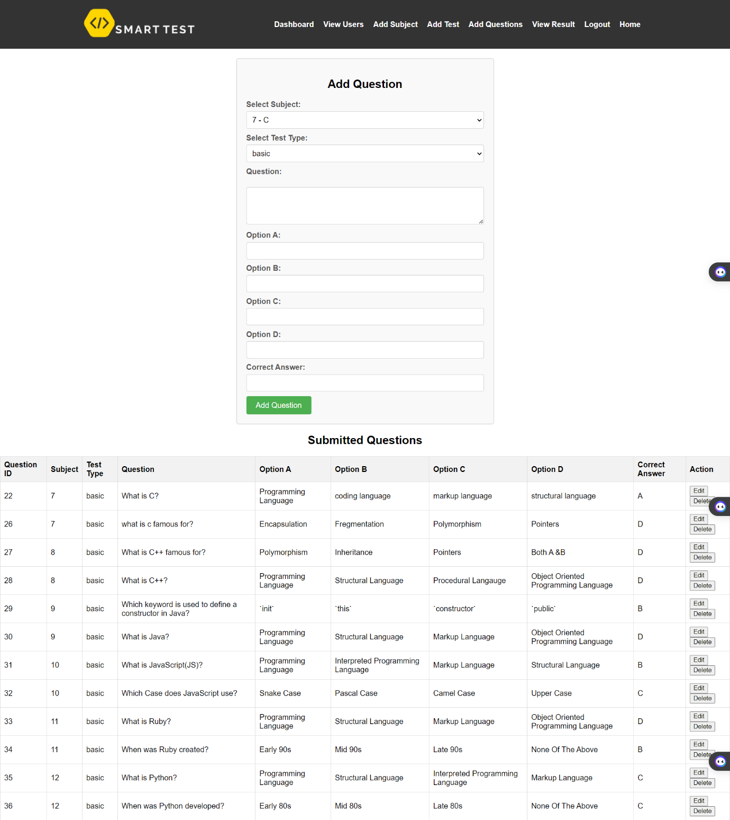

Admin can view results of all the users.

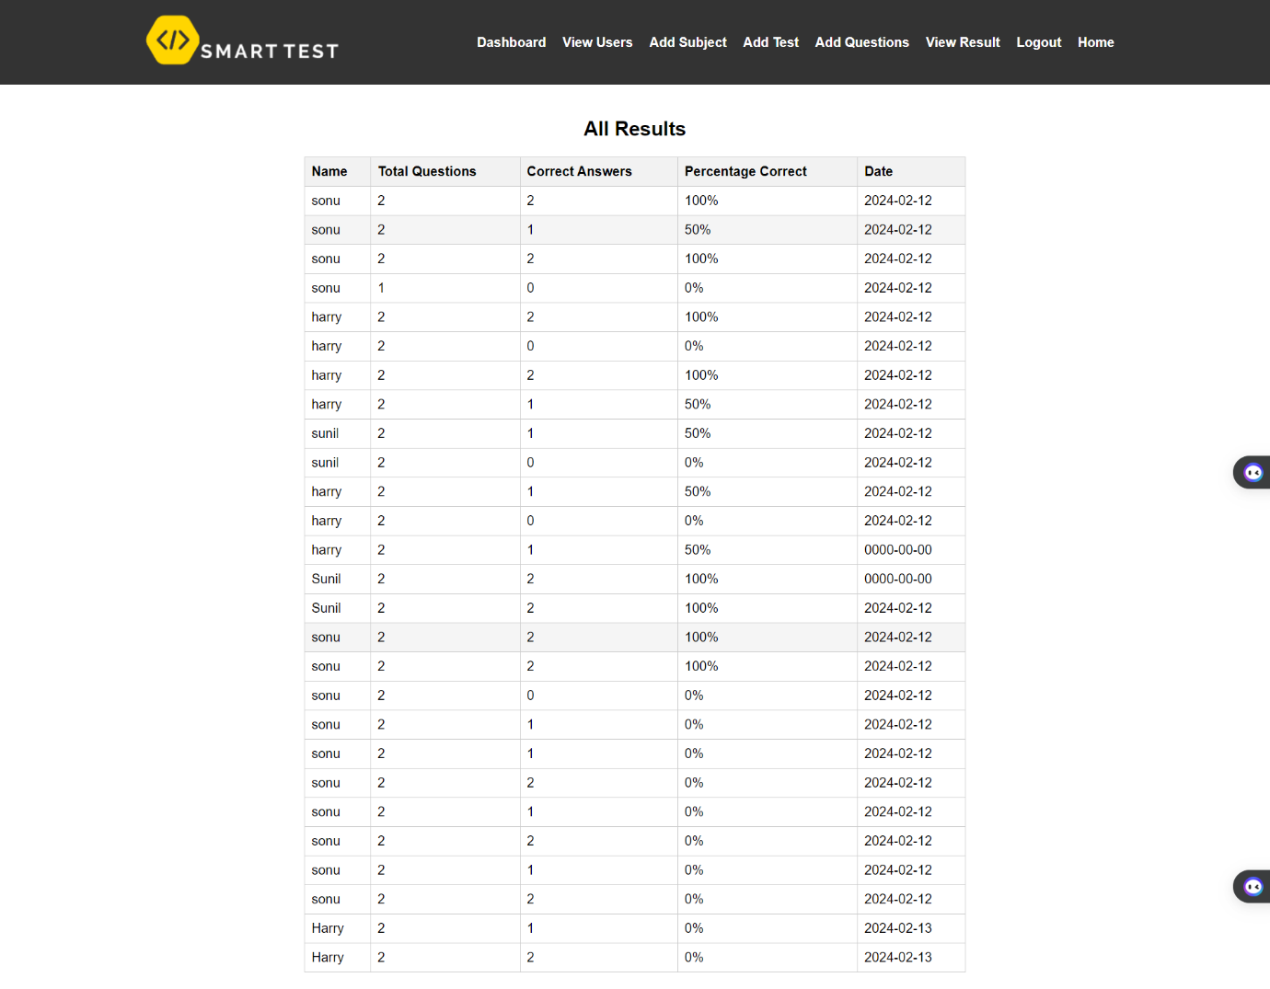

# 

# Database Tables

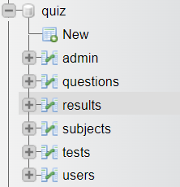

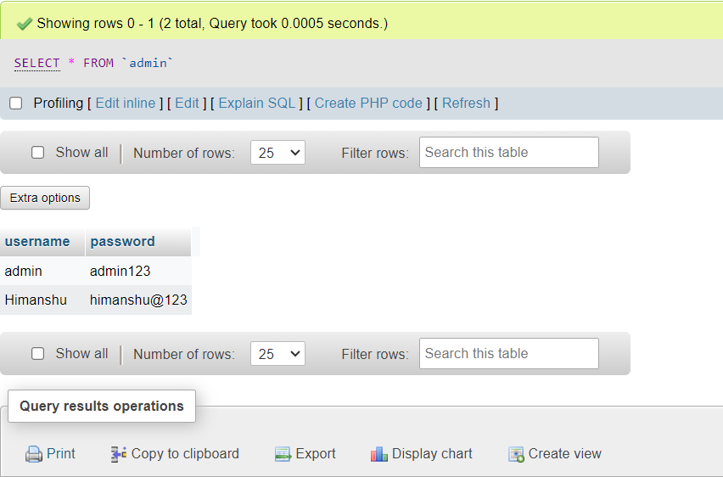

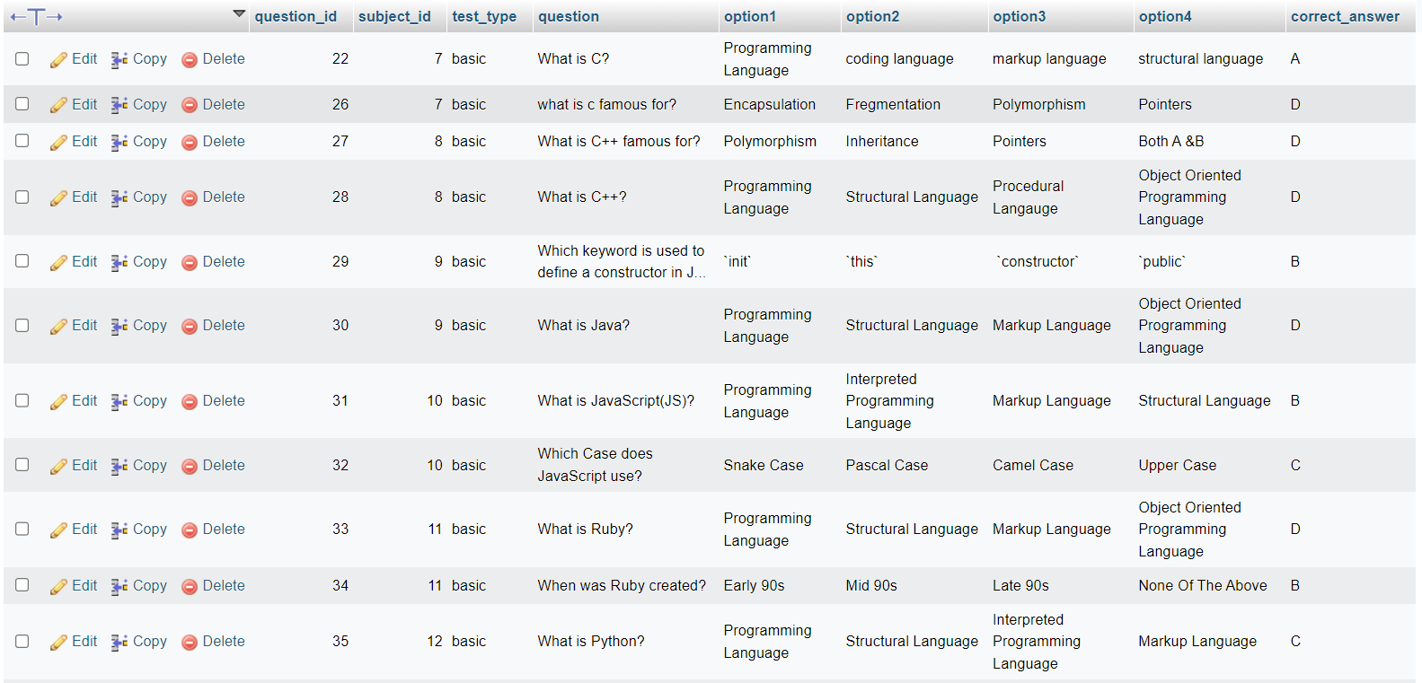

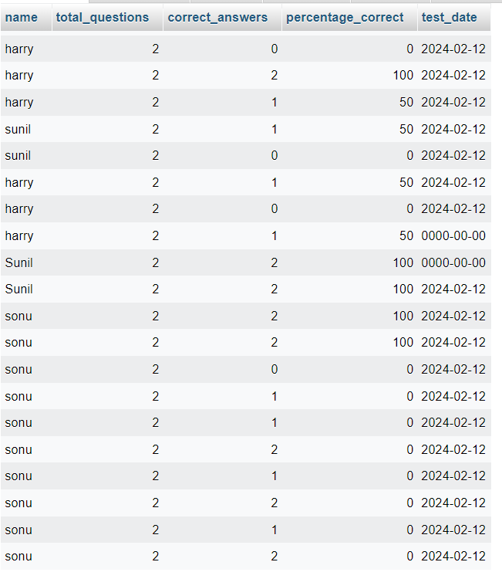

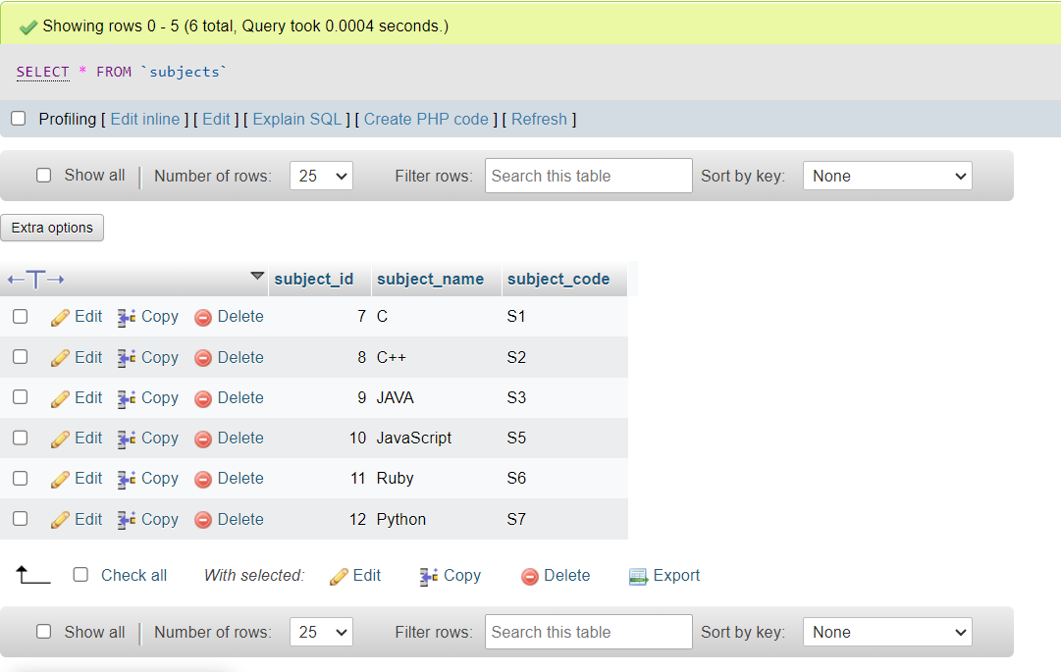

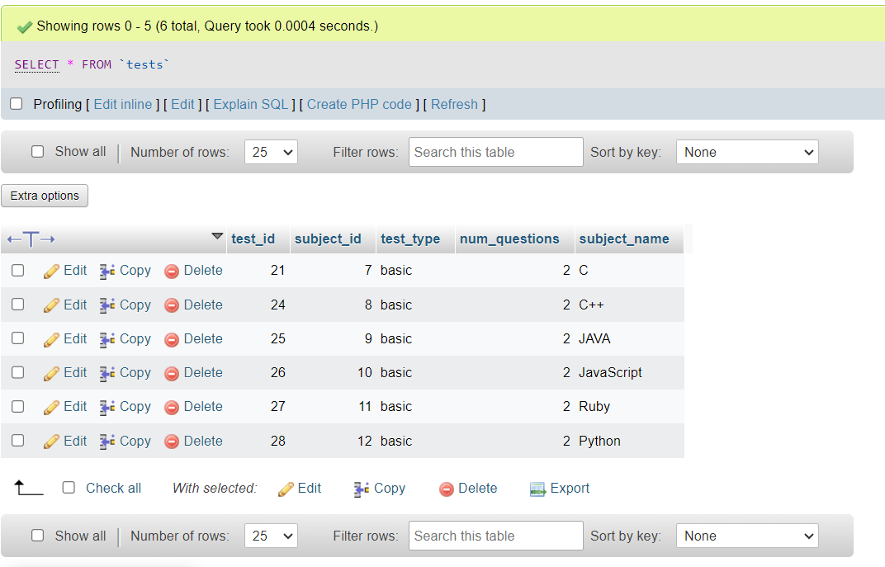

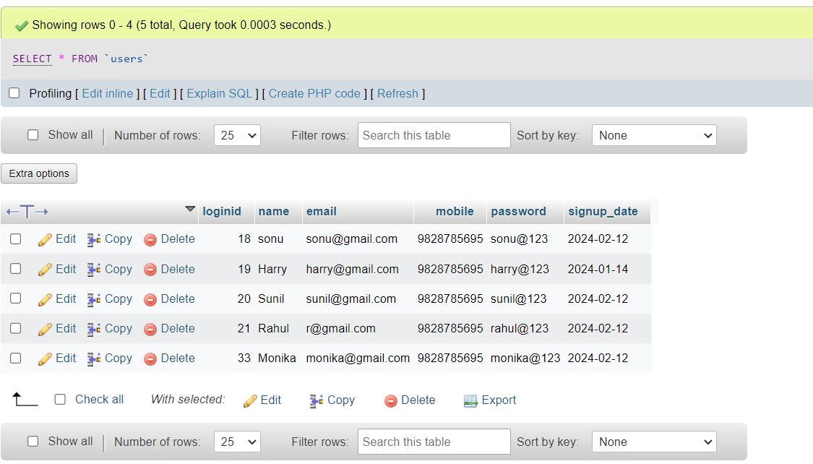

# Limitations

When developing a smart test quiz website, it's important to consider potential limitations and challenges, including those associated with features like Google Sign-In. Here are some common limitations and considerations:

1. Dependency on Third-Party Services

- Service Availability: Reliance on Google Sign-In means that if Google services experience downtime or disruptions, users may not be able to log in.

- API Changes: Google may update or change their API, requiring ongoing maintenance and updates to your integration.

2. Privacy and Security Concerns

- Data Sharing: Users might be hesitant to share their Google account information due to privacy concerns.

- Compliance: Ensuring compliance with data protection regulations (e.g., GDPR, CCPA) can be complex when integrating third-party sign-in options.

3. User Experience Issues

- Limited Customization: Customization options for the sign-in interface might be limited, which could affect the user experience.

- Account Linking: Users might have issues linking their Google account with existing accounts on your platform, causing confusion or frustration.

4. Access Restrictions

- Blocked Services: In some regions or institutions, access to Google services might be restricted, limiting the ability of users to log in.

- Age Restrictions: Google Sign-In has age restrictions, which might prevent younger users from accessing the platform if they don’t meet the minimum age requirement.

5. Integration Complexity

- Technical Challenges: Integrating Google Sign-In requires a certain level of technical expertise and can be complex, especially for developers with limited experience.

- Maintenance: Ongoing maintenance is necessary to ensure the integration remains functional and secure, which can be resource-intensive.

6. User Dependency on Google

- Single Point of Failure: If users primarily use Google Sign-In, any issues with their Google account (e.g., being locked out) will prevent them from accessing your platform.

- Limited Alternatives: Over-reliance on Google Sign-In may discourage users who prefer not to use Google services or do not have a Google account.

7. Branding and Trust Issues

- Trust Issues: Some users may distrust third-party sign-ins due to concerns about security and data privacy.

- Branding: Relying on Google Sign-In can detract from your platform’s own branding and user experience.

8. Analytics and Data Ownership

- Limited Data Access: Using Google Sign-In may limit the type of user data you can collect, as some information will be managed by Google.

- Data Dependency: Your platform may become dependent on the data provided by Google, which may not include all the information you need.

9. Compatibility Issues

- Browser Compatibility: Ensure that Google Sign-In works seamlessly across different browsers and devices.

- Third-Party Cookie Restrictions: Increasing restrictions on third-party cookies can affect the functionality of Google Sign-In.

10. User Management Challenges

- Account Recovery: Users may face difficulties recovering their accounts if they forget their Google credentials or lose access to their Google account.

- Multiple Accounts: Handling users with multiple Google accounts can be challenging, especially if they accidentally sign in with the wrong one.

# Future Scope

The future scope for a smart test quiz website is vast and promising due to the increasing demand for personalized and adaptive learning solutions. Here are several key areas where such a platform could evolve:

1. Adaptive Learning and AI Integration

- Personalized Quizzes: Use AI to create personalized quizzes that adapt to the user’s learning pace and knowledge level.

- Predictive Analytics: Analyze user performance to predict outcomes and recommend areas of improvement.

- Natural Language Processing: Implement NLP for better understanding of user inputs and to create more dynamic and interactive quizzes.

2. Gamification

- Achievements and Rewards: Introduce badges, leaderboards, and rewards to motivate users.

- Interactive Elements: Incorporate interactive elements like animations and game-based scenarios to make quizzes more engaging.

3. Data Analytics and Insights

- Performance Tracking: Provide detailed analytics on user performance, including strengths and weaknesses.

- Feedback Mechanisms: Implement advanced feedback systems to guide users on how to improve their skills.

4. Integration with Educational Platforms

- LMS Integration: Integrate with Learning Management Systems (LMS) for seamless use in educational institutions.

- Content Partnerships: Collaborate with educational content providers to offer a wide range of topics and courses.

5. Mobile and Offline Accessibility

- Mobile Apps: Develop mobile applications for iOS and Android to allow users to take quizzes on the go.

- Offline Mode: Enable offline access to quizzes, so users can practice without an internet connection.

6. Diverse Content Formats

- Multimedia Quizzes: Include various content formats like videos, audio clips, and interactive simulations in quizzes.

- Real-time Scenarios: Use VR and AR to create immersive quiz experiences based on real-life scenarios.

7. Community and Collaboration Features

- Peer Reviews: Allow users to create and review quizzes for their peers.

- Discussion Forums: Create forums where users can discuss quiz questions and share knowledge.

8. Corporate and Professional Training

- Skill Assessments: Offer quizzes tailored for professional skills assessment and certification.

- Employee Training Programs: Develop quizzes for corporate training programs to help with employee development and compliance training.

9. Global Reach and Multilingual Support

- Localization: Provide multilingual support to cater to a global audience.

- Cultural Adaptation: Adapt content to be culturally relevant to different regions.

10. Security and Privacy

- Data Protection: Ensure robust security measures to protect user data.

- Compliance: Stay compliant with regulations like GDPR to maintain user trust.

# Conclusion

Integrating features like Google Sign-In into a smart test quiz website offers significant advantages, such as streamlined user experiences and enhanced convenience. However, it also introduces several limitations and challenges, including dependency on third-party services, privacy and security concerns, potential user experience issues, and technical complexities.

Addressing these limitations requires careful planning and ongoing maintenance. Ensuring compliance with data protection regulations, providing alternative login options, and maintaining robust security measures are essential to mitigate the risks associated with third-party integrations. Additionally, focusing on user education about the benefits and potential risks of using third-party sign-ins can help build trust and improve user adoption.

By proactively managing these challenges, a smart test quiz website can leverage the benefits of Google Sign-In while minimizing potential drawbacks, ultimately providing a more reliable, secure, and user-friendly platform for learners and educators alike.

# References

* https://www.perceptionsystem.com/blog/15-job-portal-website-features-for-recruitment-experience/
* https://djtechblog.com/php/login-logout-using-session/
* https://www.geeksforgeeks.org/how-to-fetch-data-from-the-database-in-php/
* https://www.geeksforgeeks.org/how-to-upload-image-into-database-and-display-it-using-php/
* https://stackoverflow.com/questions/35816037/a-simple-way-to-redirect-users-to-their-dashboards
* https://laracasts.com/discuss/channels/laravel/fetch-products-with-its-categoriessub-categories